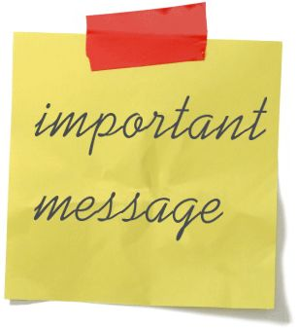
Year 3 Literacy Targets

As you know all know children learn at different rates and these are only meant to be a guideline.

Reading
The average child by the end of year 3 will know their 200 ladybird keywords with quick recall. A copy of these will be included in the appendix.

By the end of Year 3 they will be coming to the end of the schools main reading scheme i.e. Heinemann Storyworlds and possibly will have started to read some basic novels.

When reading with fluency your child will be using:-
- A variety of reading strategies to decode unfamiliar words
- Use clues from the text to make predictions
- Make inferences (read between the lines)
- Answer literal questions and questions which will go beyond the literal meaning

Spelling
When starting Year 3 your child will begin formal spellings. They will have a set number of spellings for the week and set spelling activities to complete to help them learn their spellings. They will begin with cvc words and progress as the chart below shows. (CVC mean consonant, vowel, consonant)
Examples of types of words
Cvc word | Cvcc words | Ccvc words | Consonant  Diagraphs | Vowel – e  Or magic e words
cat  dog  beg  kit  bug | cost  must  mast  milk  bend | step  gran  grip  cross  slug | shop  chip  what  thin | cape  kite  pole  cube

They will also
- Use the alphabet to locate words in a dictionary
- Put words into alphabetical order using the 1st letter
- Spell common words with more accuracy – big, the , him, mum etc.

Writing
By the end of Year 3 your child should
- Write on the line using finger spaces and well-formed letters
- They should be using tall and small letters and they should be of a consistent size
- Use basic punctuation i.e. full stops, question marks and capital letters for the date, names, titles and for the pronoun I

In Year 3 your child is introduced to joined up handwriting. It is normally about Easter before we cover all the joins. After that point I will be encouraging your child to use their joined up writing in their everyday work. There has been research to show that joining up handwriting has a positive impact on your child’s spelling ability and it is also faster.

