Dear Parents,

It has been lovely meeting my new Year 1 class and seeing the boys and girls from last year who have now become Year 2. I am looking forward to a busy and productive year ahead!! I just want to use this opportunity to update you on some information regarding our classroom routines and homework.

**Reading** – in *October* we will be working on learning key words and developing early reading skills. We will make a class book together which can be read at home every night. Key words to be learned will be on flashcards in their word box. The learning of key words will help your child to progress in their reading ability and develop fluency in their reading. Please make sure time is spent learning key words with your child.

**Formal Homework will begin in October** and will be given out every day; usually consisting of a Numeracy homework on a Monday and Wednesday night and a Literacy homework on a Tuesday and Thursday night. Sometimes this will vary and there could be a topic or PATHS homework instead. Homeworks will begin from the first week in October. Homeworks are reinforcement of learning that has been taught in school. Hopefully homeworks will be completed within a time space which is appropriate for your child. If you feel your child is taking too long or having any difficulties please do not hesitate to contact me on any matter. Please return homeworks every day. Children are encouraged to put their homework into a tray as soon as they come in each morning.

**Storysacks**

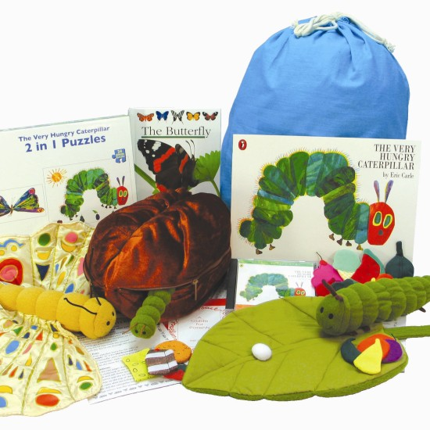

Storysacks will be available to take home from today Monday 10th September for you to borrow on a weekly basis. Storysacks provide a great opportunity for you to share books and share the enjoyment of reading with your child. Every storysack has an extensive range of activities and learning experiences. Please do not feel that you have to cover everything but rather choose activities that would attract your child’s interest and enthusiasm in reading. The Storysacks can contain lots of small toys/ pieces and we are fully aware that these can get lost very easily. Don’t worry if something goes missing but please just let us know so we can try to replace it for future users. Your child will have the chance to choose a storysack every Monday up until the hallowe’en break. Please return storysacks on Fridays or if you wish you can also have them over the weekend. As long as the previous one is returned your child can then choose a new one. Any feedback on your thoughts about the use of the storysacks is always welcome.

**After the Hallowe’en break** your child will have the opportunity to visit the library every Tuesday or Wednesday and choose books to take home with them. Please make sure that books are returned to school on or before every Tuesday.

**When your child starts homework it would be a great help if you could make sure that all the above books and word boxes are put back into their wallet every night and brought into school every day.**

**P.E.** – we will be having P.E. on a Thursday morning in school. Every Thursday your child can come to school in their P.E. kit. We will change back into uniforms after having P.E. It is important to put your child’s uniform in their bag for them to change back into.

I know that home times can be busy and it can be hard to get to talk to me but if there is ever anything you wish to talk about don’t hesitate to speak to me or arrange an appointment if needed.

Many thanks, your help and support is greatly appreciated.

Mrs Debby McGerrigle (Class teacher)

Mrs Wallace (Classroom Assistant)